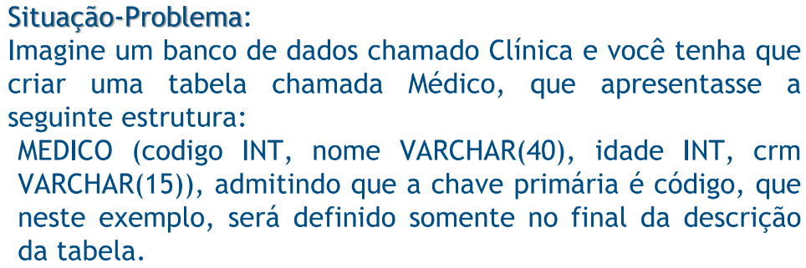

Resposta:

CREATE DATABASE Clinica;

CREATE TABLE MEDICO (

Cod_Med INT Not Null,

Nome_Med VARCHAR(10) Not Null,

Idade_Med INT Not Null,

Crm_Med VARCHAR(15) Not Null,

Primary Key (Cod_Med));

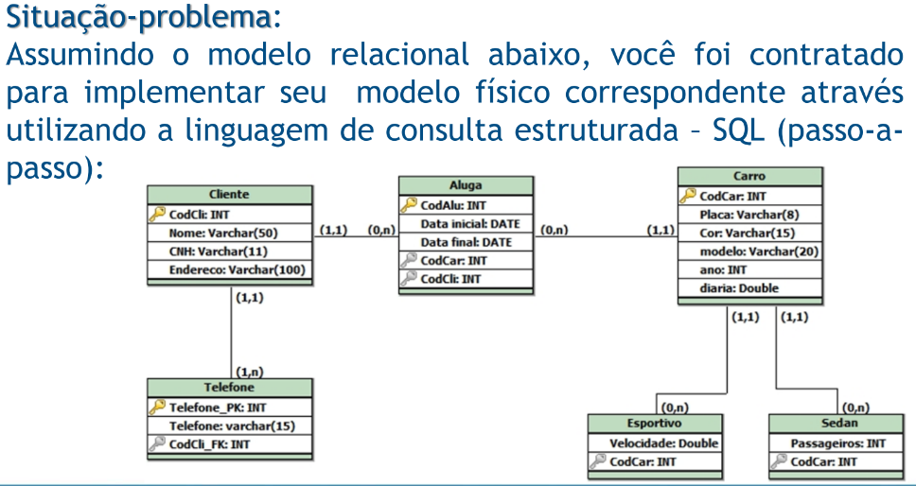

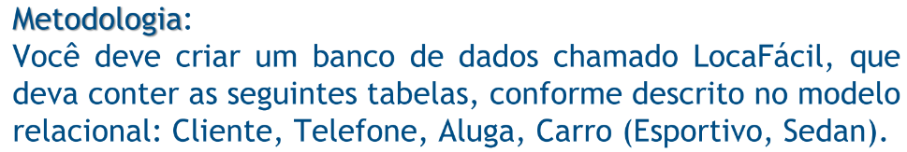

Resposta:

CREATE DATABASE LocaFacil;

CREATE TABLE Cliente (

CodCli INT Primary Key Not Null,

Nome VARCHAR (50) Not Null,

CNH VARCHAR(11) Not Null,

Endereco VARCHAR(100) Null);

CREATE TABLE Telefone (

Telefone_PK INT Primary Key Not Null,

Telefone VARCHAR(15) Null,

CodCli_Fk INT References Cliente (CodCli));

CREATE TABLE Aluga (

CodAlu INT Primary Key Not Null,

DataInicial DATE Not Null,

DataFinal DATE Not Null,

CodCar INT References Carro (CodCar),

CodCli INT References Cliente (CodCli));

CREATE TABLE Carro (

CodCar INT Primary Key Not Null,

Placa VARCHAR(8) Not Null,

Cor VARCHAR(15) Not Null,

Modelo VARCHAR(20) Not Null,

Ano INT Not Null,

Diaria DOUBLE Not Null );

CREATE TABLE Esportivo (

Velocidade DOUBLE Not Null,

CodCar INT References Carro (CodCar));

CREATE TABLE Sedan (

Passageiros INT Not Null,

CodCar INT References Carro (CodCar));

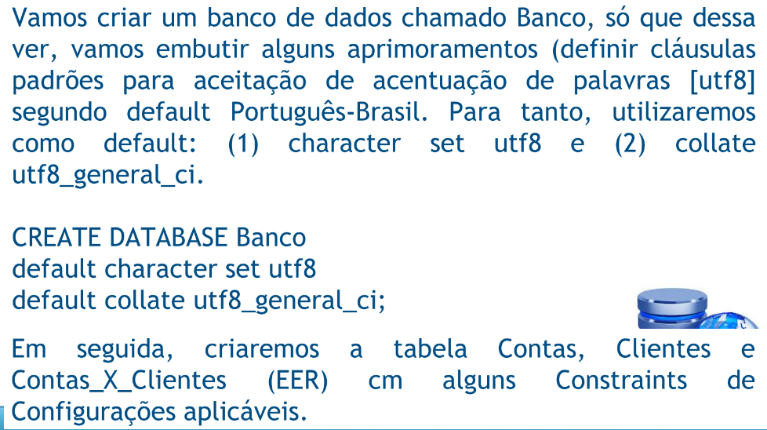

Resposta:

CREATE DATABASE Banco

default character set utf8

default collate utf8_general_ci;

CREATE TABLE Clientes(

cod_cli tinyint not null,

nome varchar(40) not null,

cpf int not null,

dt_nasc date not null,

nacional varchar (20) default ‘Brasil’,

sexo enum (‘F’, ‘M’),

email varchar(20),

tel varchar(13),

cel varchar(13),

primary key (cod_cli))

default charset = utf8;

CREATE TABLE Contas (

num_conta int not null auto_increment,

tipo varchar (15) not null,

categ enum (‘Especial’, ‘Comum’),

saldo decimal (9, 2),

Primary key (num_conta))

default charset = utf8;

CREATE TABLE Projetos_X_Pessoas(

id_cxc int not null auto_increment,

cod_cli tinyint,

num_conta int,

primary key (id_cxc),

foreign key (cod_cli) references Clientes(cod_cli),

foreign key (num_conta) references Contas(num_conta));

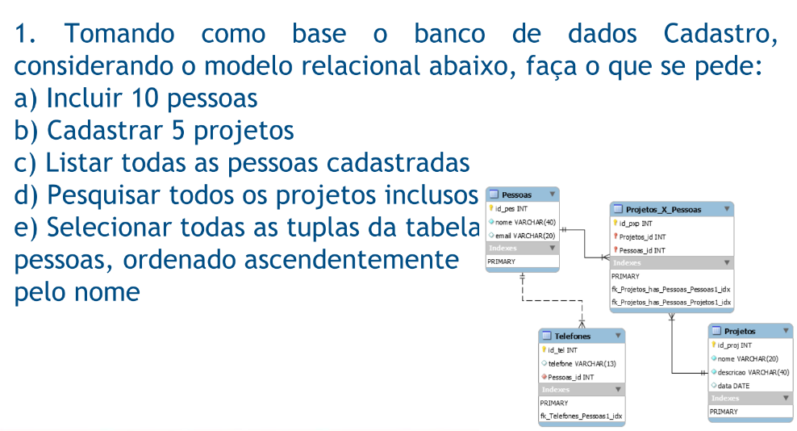

INSERT INTO Pessoas

(id, nome, email)

VALUES

(‘1’, ‘Lucas’, ‘lucas@hotmail.com’),

(‘2’, ‘Miguel’, ‘miguel@hotmail.com’),

(‘3’, ‘Sena’, ‘sena@hotmail.com’),

(‘4’, ‘Costa’, ‘costa@hotmail.com’),

(‘5’, ‘Mirella’, ‘mirella@hotmail.com’),

(‘6’, ‘Caputi’, ‘caputi@hotmail.com’’),

(‘7’, ‘Oliveira’, ‘oliveira@hotmail.com’),

(‘8’, ‘Menezes’, ‘menezes@hotmail.com’),

(‘9’, ‘Marcia’, ‘marcia@hotmail.com’),

(‘10’, ‘Anilton’, ‘anilton@hotmail.com’);

INSERT INTO Projetos

(id_proj, nome, descrição, data)

VALUES

(‘1’, ProjA, DescricaoDoProjetoA, 01/01/2010),

(‘2’, ProjB, DescricaoDoProjetoB, 03/07/2011),

(‘3’, ProjC, DescricaoDoProjetoC, 04/05/2007),

(‘4’, ProjD, DescricaoDoProjetoD, 08/06/2018),

(‘1’, ProjE, DescricaoDoProjetoE, 06/27/2023);

SELECT * FROM Pessoas;

SELECT * FROM Projetos;

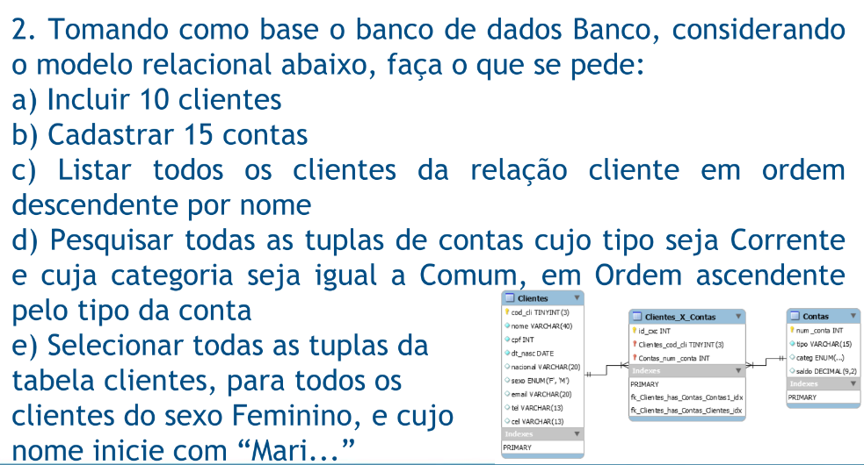SELECT *FROM Pessoas ORDER BY nome;

INSERT INTO Clientes

(cod_cli, nome, cpf, dt_nasc, nacional, sexo, email, tel, cel)

VALUES

(‘1’,‘Lucas’,’17878998756’,’06/27/2000’,’brasileira’,’M’,‘lucas@hotmail.com’,’21978985645’),

(‘2’, ‘Miguel’, ‘56445678987’,’07/13/1988’,’brasileira’,’M’,‘miguel@hotmail.com’,’21985587766’),

(‘3’, ‘Sena’,‘32145678998’,’11/05/1997’,’brasileira’,’F’,‘sena@hotmail.com’,’21754658879’),

(‘4’, ‘Costa’,‘47587966614’,’12/12/1998’,’brasileira’,’M’,‘costa@hotmail.com’,’21976547789’),

(‘5’, ‘Mirella’,’6654741436’,’06/14/1998’,’brasileira’,’F’,‘mirella@hotmail.com’,’21975477823’),

(‘6’, ‘Caputi’,’45776554745’,’10/02/2001’,’brasileira’,’F’,‘caputi@hotmail.com’,’21978451263’),

(‘7’, ‘Oliveira’,’45665414224’,’10/10/2010’,’brasileira’,’M’,‘oliver@hotmail.com’,’21978451254’),

(‘8’, ‘Menezes’,’45466574778’,’02/02/2022’,’brasileira’,’F’,‘menezes@hotmail.com’),

(‘9’, ‘Marcia’,’6658799878’,’01/28/1979’,’brasileira’,’F’,‘marcia@hotmail.com’,’21970187485’),

(‘10’, ‘Anilton’,’8458744796’,’10/31/1965’,’brasileira’,’M’,‘anilton@hotmail.com’,’21986628228’);

INSERT INTO Contas

(num_conta, tipo, categ, saldo)

VALUES

(‘1’,‘Corrente’, ‘Especial’, ‘2598.55’),

(‘2’,‘Poupança’, ‘Comum’, ‘1050.38’),

(‘3’,‘Poupança’, ‘Especial’, ‘2000.99’),

(‘4’,‘Corrente’, ‘Comum’, ‘680.59’),

(‘5’,‘Corrente’, ‘Especial’, ‘123.55’),

(‘6’,‘Poupança’, ‘Comum’, ‘1234.38’),

(‘7’,‘Poupança’, ‘Especial’, ‘20.99’),

(‘8’,‘Corrente’, ‘Comum’, ‘1890.59’),

(‘9’,‘Corrente’, ‘Especial’, ‘2222.22’),

(‘10’,‘Poupança’, ‘Comum’, ‘10.50’),

(‘11’,‘Poupança’, ‘Especial’, ‘10000.09’),

(‘12’,‘Corrente’, ‘Comum’, ‘68.25’),

(‘13’,‘Corrente’, ‘Especial’, ‘1225.75’),

(‘14’,‘Poupança’, ‘Comum’, ‘983.28’),

(‘15’,‘Poupança’, ‘Especial’, ‘170.10’);

SELECT *FROM Clientes ORDER BY nome DESC;

SELECT *FROM Contas WHERE tipo=’Corrente’ and categ=’Comum’ ORDER BY tipo;

SELECT *FROM Clientes WHERE sexo=’F’ and nome like ‘Mari%’;

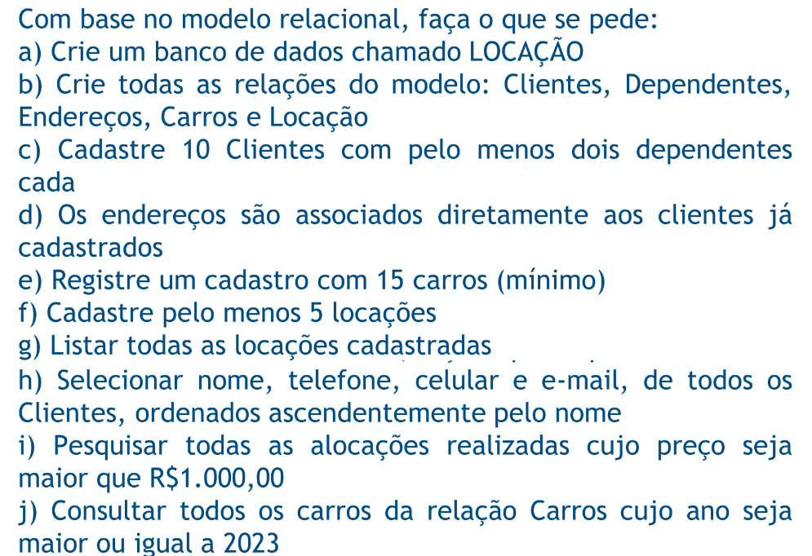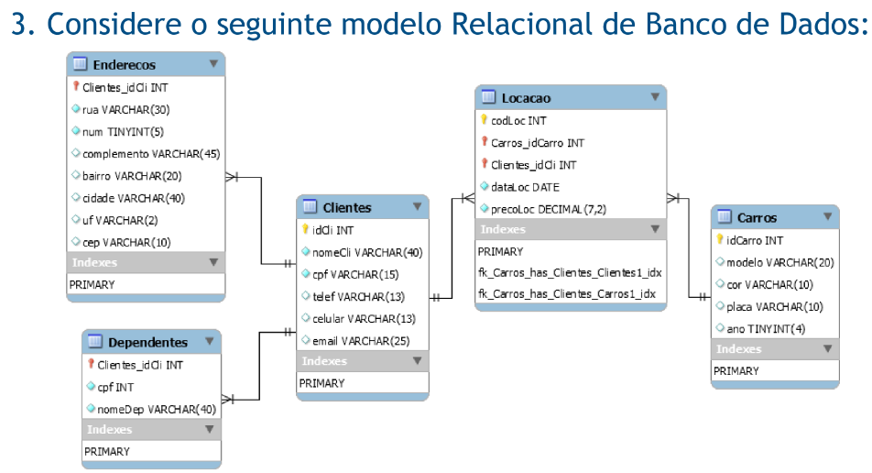

CREATE DATABASE LOCACAO;

default character set utf8

default collate utf8_general_ci;

CREATE TABLE Clientes (

IdCl INT Primary Key Auto_Increment,

nomeCli VARCHAR(40) Not Null,

cpf VARCHAR(13) Not Null,

telef VARCHAR(13) Null,

celular VARCHAR (13) Null,

email VARCHAR(25) Not Null),

default charset = utf8;

CREATE TABLE Dependentes (

Clientes_id INT Primary Key Auto_Increment,

cpf INT Not Null,

nomeDep VARCHAR(40) Not Null),

default charset = utf8;

CREATE TABLE Enderecos (

Clientes_idCl INT Primary Key Auto_Increment,

Rua VARCHAR(30) Not Null,

Num TINYINT(5) Not Null,

Complemento VARCHAR(45) Null,

Bairro VARCHAR(20) Not Null,

Cidade VARCHAR(40) Not Null,

Uf VARCHAR(2) Not Null,

Cep VARCHAR(10) Not Null)

default charset = utf8;

CREATE TABLE Carros (

idCarro INT Primary Key Auto_Increment,

modelo VARCHAR(20) Not Null,

cor VARCHAR(10) Not Null,

placa VARCHAR(10) Not Null,

ano TINYINT(4) Not Null)

default charset = utf8;

CREATE TABLE Locacao (

codLoc INT Primary Key Auto_Increment,

Carros_idCarro INT References Carros(idCarro),

Clientes_idCli INT References Clientes(IdCl),

DataLoc DATE Not Null,

preloLoc DECIMAL(7,2) Not Null)

default charset = utf8;

